**ACKNOWLEDGEMENT**

We take this occasion to thank almighty Allah for blessing us with his grace and taking our endeavor to a successful culmination. We extend our sincere and heartfelt thanks to our esteemed guide, **Md. Sumon Mia**, for providing us with the right guidance and advice at the crucial junctures and for showing me the right way. We also take this opportunity to express a deep sense of gratitude to our class coordinator, **Mithun Kumar** for his cordial support, valuable suggestions and guidance. We extend our sincere thanks to our respected head of the Department **Dr. Mirza A.F.M. Rashidul Hasan** , for allowing us to use the facilities available. We would like to thank the other faculty members also, at this occasion. Last but not the least, we would like to thank our friends and family for the support and encouragement they have given us during the course of our work.

**TABLE OF CONTENTS**

**ABSTRACT**

1. INTRODUCTION
2. PROJECT AIMS AND OBJECTIVES
3. BACKGROUND OF PROJECT
4. SOFTWARE REQUIREMENT SPECIFICATION
5. EXISTING VS PROPOSED
6. SYSTEM DESIGN
7. SYSTEM BUILD & IMPLEMENTATION
8. SYSTEM TESTING

10.CONCLUSION & FUTURE SCOPE

11.REFERENCES

**ABSTRACT**

An **automated teller machine** (**ATM**) is an electronic telecommunications device that enables customers of [financial institutions](https://en.wikipedia.org/wiki/Financial_institution) to perform [financial transactions](https://en.wikipedia.org/wiki/Financial_transaction), such as cash withdrawals, deposits, transfer funds, or obtaining account information, at any time and without the need for direct interaction with bank staff. ATMs are known by a variety of names, including **automatic teller machine** ( **ATM**, [American](https://en.wikipedia.org/wiki/American_English), [British](https://en.wikipedia.org/wiki/British_English), [Australian](https://en.wikipedia.org/wiki/Australian_English), [Malaysian](https://en.wikipedia.org/wiki/Malaysian_English), [South African](https://en.wikipedia.org/wiki/South_African_English), [Singaporean](https://en.wikipedia.org/wiki/Singaporean_English), [Indian](https://en.wikipedia.org/wiki/Indian_English), [Maldivian](https://en.wikipedia.org/wiki/Maldivian_English), [Hiberno](https://en.wikipedia.org/wiki/Hiberno-English" \o "Hiberno-English), [Philippines](https://en.wikipedia.org/wiki/Philippine_English) and Sri Lankan), often [redundantly](https://en.wikipedia.org/wiki/RAS_syndrome) **ATM machine**, **automated banking machine** (**ABM**,), **cash point** (British), **cashline**, **minibank**, **cash machine** etc. Many ATMs have a sign above them, indicating the name of the bank or organization that owns the ATM, and possibly including the networks to which it can connect. In Canada, ABM that are not operated by a financial institution are known as ["white-label ABMs"](https://en.wikipedia.org/wiki/White-label_ABMs_in_Canada).

According to the [ATM Industry Association (ATMIA)](https://en.wikipedia.org/wiki/ATMIA), there are now close to 3.5 million ATMs installed worldwide. However, the use of ATMs is gradually declining – most notably in retail precincts.

On most modern ATMs, customers are identified by inserting a plastic [ATM card](https://en.wikipedia.org/wiki/ATM_card) (or some other acceptable payment card) into the ATM, with authentication being by the customer entering a [personal identification number](https://en.wikipedia.org/wiki/Personal_identification_number) (PIN) which must match the PIN stored in the chip on the card (if the card is so equipped) or in the issuing financial institution's database.

Using an ATM, customers can access their bank deposit or credit accounts in order to make a variety of financial transactions such as [cash](https://en.wikipedia.org/wiki/Cash) withdrawals, check balances, or credit mobile phones. ATMs can be used to withdraw cash in a foreign country. If the currency being withdrawn from the ATM is different from that in which the bank account is denominated, the money will be converted at the financial institution’s [exchange rate](https://en.wikipedia.org/wiki/Exchange_rate).

Our project’s aim is to make the whole banks ATM system of Bangladesh improved to a great extent. But we can’t do that unless all the banking systems are highly updated & must come with advanced feature & security updates.

**INTRODUCTION**

Our project is called “**ATM Banking System**”, in short “ATM Banking”.

Bangladesh is a developing country. But, still, there are some areas which is underdeveloped. The banking system is somewhere developing, and somewhere remains underdeveloped.  
  
ATM stands for Automated teller machine. Presently this is one of the most improvised ways of transaction. As people do not feel comfortable to carry huge amount of money in our country for huge security issue, they use ATMs. By adding new features and also increasing the security issues it may provide more supremacy than it today. As a result, life becomes reliable and lighten up. Here in this paper we tried to give a full description, how Advanced ATM works and comparisons among the general ATM services of different banks in Bangladesh. We also tried to focus few problems and few suggestions how to eliminate these problems.  
  
Our project’s aim is to make the whole banks ATM system of Bangladesh improved to a great extent. But we can’t do that unless all the banking systems are highly updated & must come with advanced feature & security updates.

**PROJECT AIMS AND OBJECTIVES**

Bangladesh is a developing country. But, still, there are some areas which is underdeveloped. The banking system is somewhere developing, and somewhere remains underdeveloped.

Our objective is to create a more improved ATM banking system for banks of Bangladesh and make banking more secured & immediate emergency usable, safe and easier for people. But, to improve this system, we need to accomplish the following things:

1. Highly secured encrypted database.

2. Improved database & server Tracking System

3. Improved Online transaction

4. All advanced Features in ATM machine.

5. Highly secured website for everything about banking detail.

6. Advanced featured ATM in booth for everything in every crowed place, at any need or emergency that can be most usable for fastest banking & transaction all over the world.

**BACKGROUND OF PROJECT**

ATMs can be placed at any location but are most often placed near or inside banks, shopping centers/malls, airports, [railway stations](https://en.wikipedia.org/wiki/Railway_station), [metro stations](https://en.wikipedia.org/wiki/Metro_station), grocery stores, petrol/gas stations, restaurants, and other locations. ATMs are also found on [cruise ships](https://en.wikipedia.org/wiki/Cruise_ship) and on some Military ships, where sailors can draw out their pay.

ATMs may be on- and off-premises. On-premises ATMs are typically more advanced, multi-function machines that complement a bank branch's capabilities, and are thus more expensive. Off-premises machines are deployed by financial institutions and Independent Sales Organizations (ISOs) where there is a simple need for cash, so they are generally cheaper single function devices.

The Bangladesh ATM industry has seen explosive growth in recent times. ATMs represent the single largest investment in the electronic channel services for the Banks. As at the end of December 2016, the number of ATMs deployed in Bangladesh was 9019. Most of the ATMs are installed in the divisional cities and district-level town. Around 44% ATMs are installed in Dhaka City. A very few ATMs are being operated in rural areas, less than 4.84%. It is mentionable that 46% of ATMs is set up by Dutch-Bangla Bank Limited (DBBL) alone. Among 9019 ATMs, 95.54% are setup by Private Commercial Banks, 1.48% by State-Owned Commercial Banks, 0.26% by Specialized Banks and rest of the 2.58% by Foreign Commercial Banks.

Presently this is one of the most improvised ways of transaction. As people do not feel comfortable to carry huge amount of money in our country for huge security issue, they use ATMs. By adding new features and also increasing the security issues it may provide more supremacy than it today. As a result, life becomes reliable and lighten up. Here in this paper we tried to give a full description, how Advanced ATM works and comparisons among the general ATM services of different banks in Bangladesh. We also tried to focus few problems and few suggestions how to eliminate these problems. We’re about go through it.

**SOFTWARE REQUIREMENT SPECIFICATION**

For our development purpose we’ve some requirements that are very important to build our project properly. Those Software are:

1. JAVA Based Development Software
2. Database Software

We’ve used NetBeans as JAVA based Development kit & for database , we’ve used SQLite (Specially an addon for Mozilla Firefox makes it easier for us to use).

**NetBeans** is a [software development](https://en.wikipedia.org/wiki/Software_development) [platform](https://en.wikipedia.org/wiki/Platform_(computing)) written in [Java](https://en.wikipedia.org/wiki/Java_(programming_language)). The NetBeans Platform allows applications to be developed from a set of modular [software components](https://en.wikipedia.org/wiki/Software_component) called *modules*. Applications based on the NetBeans Platform, including the NetBeans [integrated development environment](https://en.wikipedia.org/wiki/Integrated_development_environment) (IDE), can be extended by [third party developers](https://en.wikipedia.org/wiki/Third_party_developer). The NetBeans IDE is primarily intended for development in Java, but also supports other languages, in particular [PHP](https://en.wikipedia.org/wiki/PHP), [C](https://en.wikipedia.org/wiki/C_(programming_language))/[C++](https://en.wikipedia.org/wiki/C%2B%2B)and [HTML5](https://en.wikipedia.org/wiki/HTML5). NetBeans is [cross-platform](https://en.wikipedia.org/wiki/Cross-platform) and runs on [Microsoft Windows](https://en.wikipedia.org/wiki/Microsoft_Windows), [macOS](https://en.wikipedia.org/wiki/MacOS), [Linux](https://en.wikipedia.org/wiki/Linux), [Solaris](https://en.wikipedia.org/wiki/Solaris_(operating_system)) and other platforms supporting a compatible [JVM](https://en.wikipedia.org/wiki/Java_Virtual_Machine).

**SQLite** is a [relational database management system](https://en.wikipedia.org/wiki/Relational_database_management_system) contained in a [C](https://en.wikipedia.org/wiki/C_(programming_language)) programming [library](https://en.wikipedia.org/wiki/Library_(computer_science)). In contrast to many other database management systems, SQLite is not a [client–server](https://en.wikipedia.org/wiki/Client%E2%80%93server) database engine. Rather, it is embedded into the end program. SQLite is [ACID](https://en.wikipedia.org/wiki/ACID)-compliant and implements most of the [SQL](https://en.wikipedia.org/wiki/SQL) standard, using a dynamically and weakly [typed](https://en.wikipedia.org/wiki/Data_type) SQL [syntax](https://en.wikipedia.org/wiki/Syntax) that does not guarantee the [domain integrity](https://en.wikipedia.org/wiki/Domain_integrity).

SQLite is a popular choice as [embedded database](https://en.wikipedia.org/wiki/Embedded_database) software for local/client storage in [application software](https://en.wikipedia.org/wiki/Application_software) such as [web browsers](https://en.wikipedia.org/wiki/Web_browser). It is arguably the most widely deployed [database engine](https://en.wikipedia.org/wiki/Database_engine), as it is used today by several widespread browsers, [operating systems](https://en.wikipedia.org/wiki/Operating_system), and [embedded systems](https://en.wikipedia.org/wiki/Embedded_system) (such as mobile phones), among others. SQLite has [bindings](https://en.wikipedia.org/wiki/Language_binding) to many programming languages.

**EXISTING VS PROPOSED**

Existing Parts :

1. Digital Display
2. Online Banking
3. Withdrawal
4. Receipt
5. Transaction

Proposed Parts :

1. Deposit
2. Balance Check
3. Emergency Loan
4. Short Loan
5. Foreign Transaction
6. High Security

**SYSTEM DESIGN**

**Welcome Panel:**

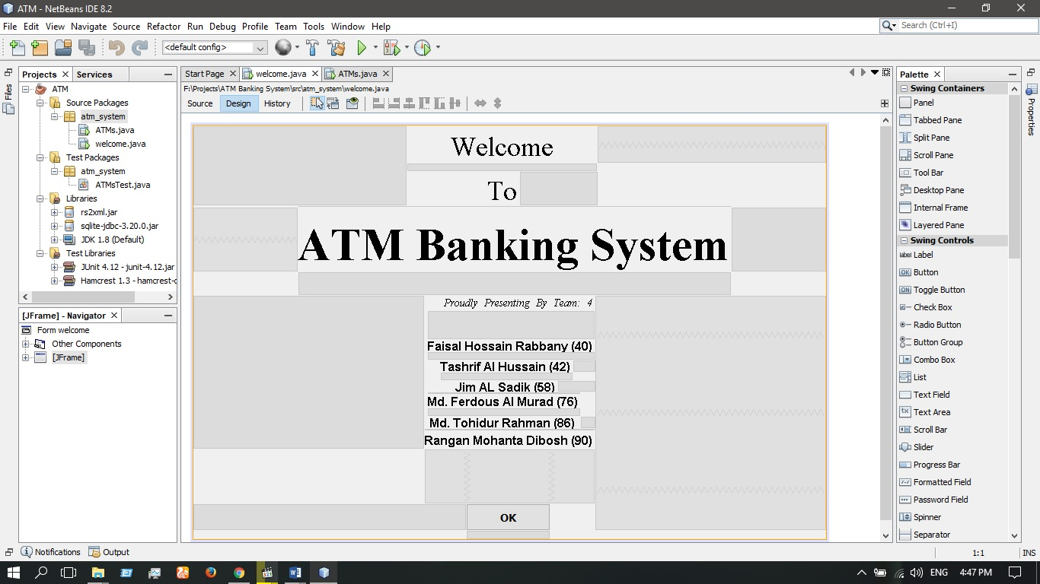

**Working/ Banking Panel:**

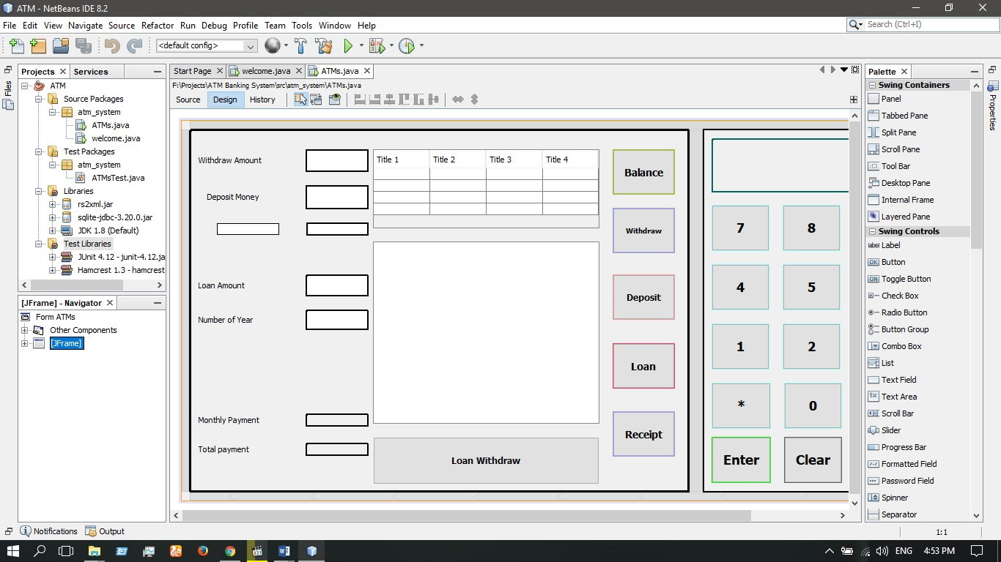

**SYSTEM BUILD**

**Database:**

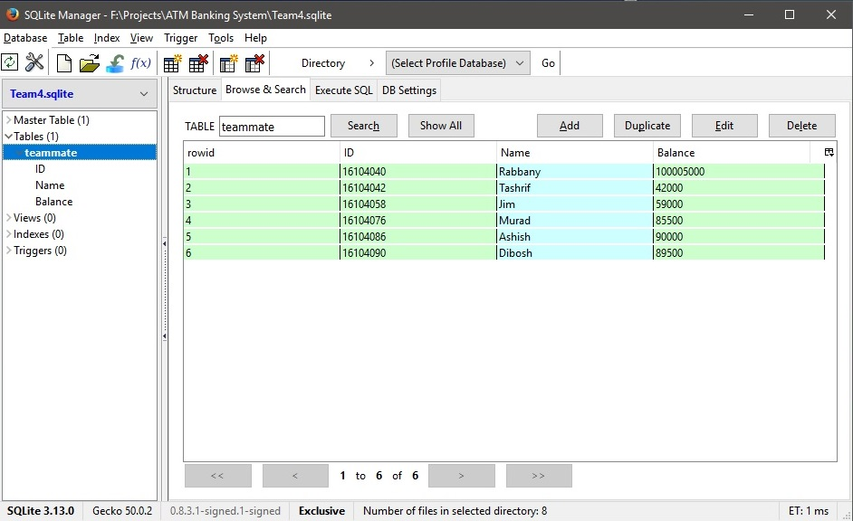

**Database Connection With JAVA program:**

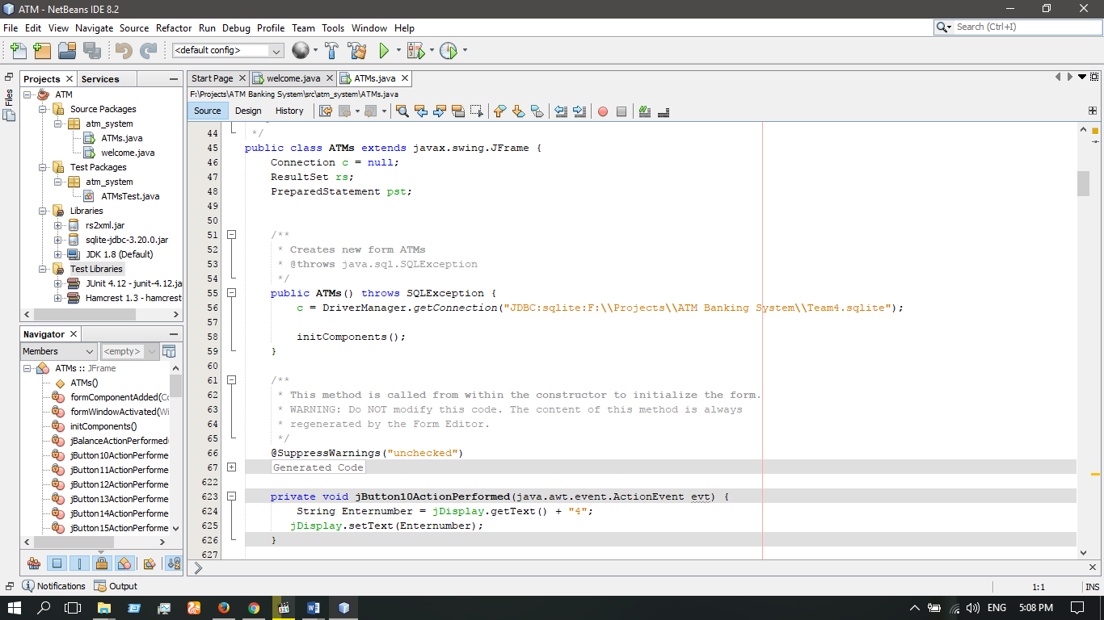

**ATM Panel Designing:**

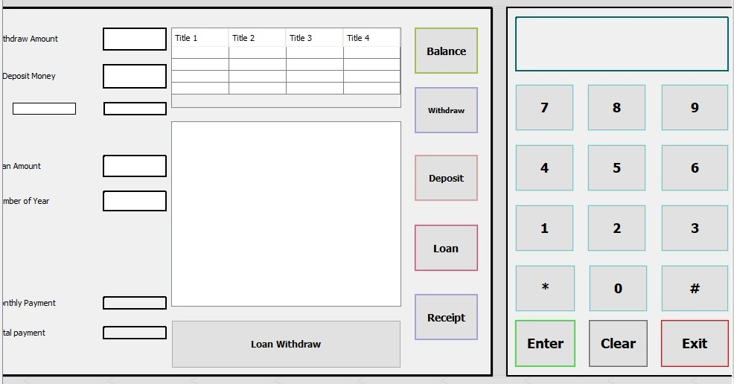

**Query :**

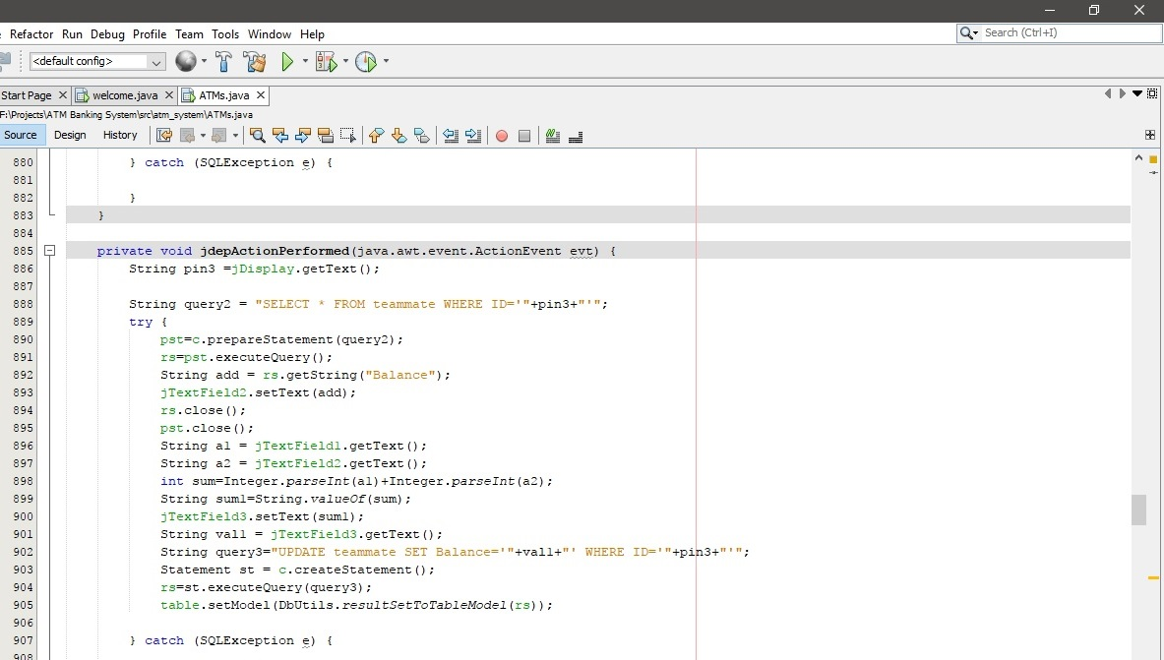

**SYSTEM TESTING**

Welcome Panel:

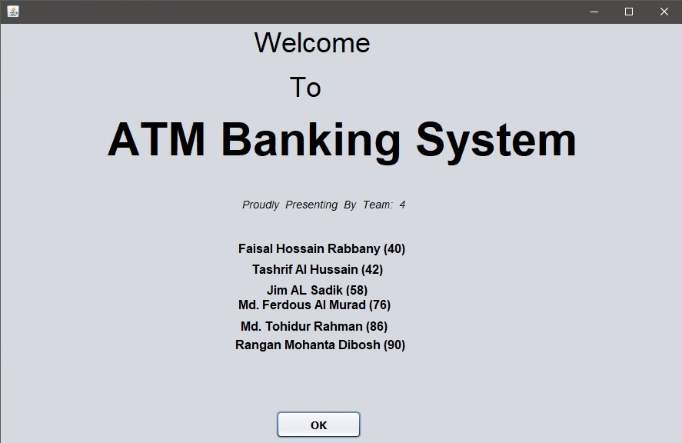

Banking Panel:

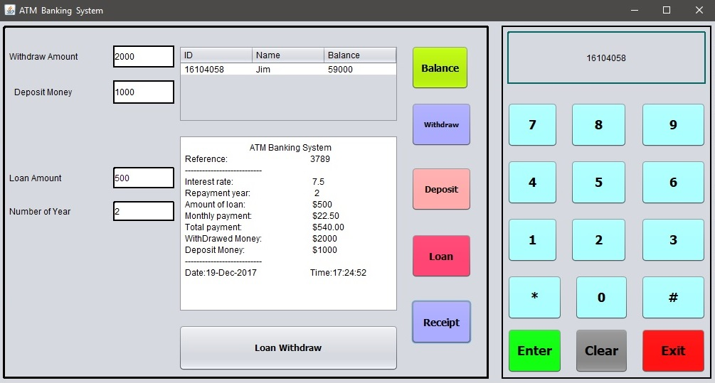

**CONCLUSION & FUTURE SCOPE**

Technology-intensive delivery channels, like Automated Teller Machines (ATMs), have created a win-win situation by extending greater convenience and multiple options for customers while providing tremendous cost advantages to the banks. ATM banking is convenient and time saving to use as it acts like “mini bank” providing cash to the needy customers at anytime, anywhere whenever and wherever there is an ATM counter.

ATMs have gained tremendous popularity as a delivery channel for banking transactions in Bangladesh and has shown explosive growth in recent times. Approximately, Taka 1,500 crore has been invested in this sector by the banks. ATMs represent the single largest investment in the electronic channel services for the banks. While ATMs facilitate a variety of banking transactions for customers, their main utility has been for cash withdrawal and balance enquiry. To attract customers not only to withdraw cash from ATMs, new technologies can be introduced to provide Value Added Services (VAS) like fund transfer to other accounts, credit card payments, mobile banking, utility bill payment, top up, etc. This will increase the customers’ convenience and also make it a profitable channel for banks. Banks should be able to provide enhanced interactivity, diversified offerings, as well as facilitate customers to participate in improving the service encounter with ATM and make it a memorable and pleasant experience. The rapid increase in the number of automated delivery channels and customers’ preference to use ATM because multifaceted attributes are creating pressure on banks to respond aggressively to meet the customers’ needs. The study provides necessary policy input to the bank management to increase customers’ satisfaction through improving ATM service quality. Banks should develop strategies to motivate non-users of ATM service through awareness, education, extending personalized services, and demonstrating the functions of ATMs. Quick response to customers’ needs and queries about the ATM-related services are important to improve the service standards of ATM. This would help customers to participate in improvement of service quality, learn and perform, and have a pleasant experience through two-way communication.

Most of the ATMs are installed in the divisional cities and district towns. Around 44% ATMs are installed in Dhaka City. Very few ATMs are however being operated in rural areas (less than 4.84%). It is mentionable that 46% of the ATMs has been set up by DBBL alone. Other banks should come forward to install more ATMs, mainly in rural areas, to expand the network. The banks may identify more locations for establishing new ATMs; however, if it is not possible either due to non-availability of space or resources crunch, they can have mutual cooperation in setting up new ATMs at suitable locations and sharing existing ATMs so that customers are able to do ATM transaction in the places where there is no ATM of their own bank. This will further enhance the customers’ satisfaction.

However, security is a great concern and frauds are increasing worldwide highly. It is seen that a group of bank employees including IT people and vendor are also being involved in such type of ATM frauds. Customers’ awareness is also a great concern. Central Bank including all banks must take special care in this regard.

**REFERENCES**

* Wikipedia.org [Data & Resource]
* Google.com [Search Engine]
* Youtube.com [Tutorials & Resources]
* Udemy.com [Tutorials]
* Linda.com [Tutorials & Resources]
* City Bank Ltd., NSU Branch [ATM Demo]
* AB Bank Ltd., NSU Branch [ATM Demo]
* Md. Jahangir Hossein [Python, Database, JAVA, Web, Artificial Intelligence Programmer & Developer]